Date 17-10-2022

**JavaScript-Lecture-Assignment-3**

## **Assignment on : Object Oriented programming concept**

**Questions** :Accepting data for student class which have 3 instances and display the data .

1. 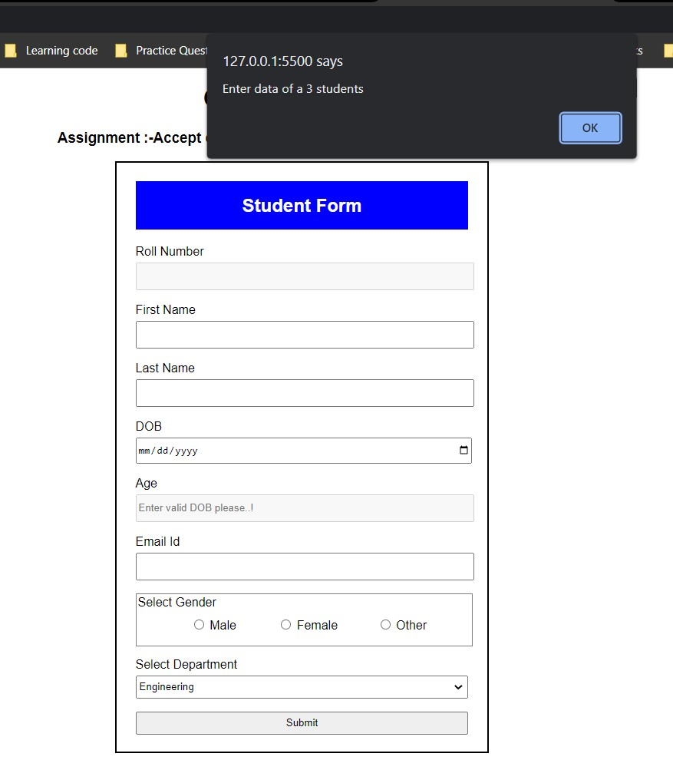after running the program

2)After click on alert button

-Roll number is automatically generated

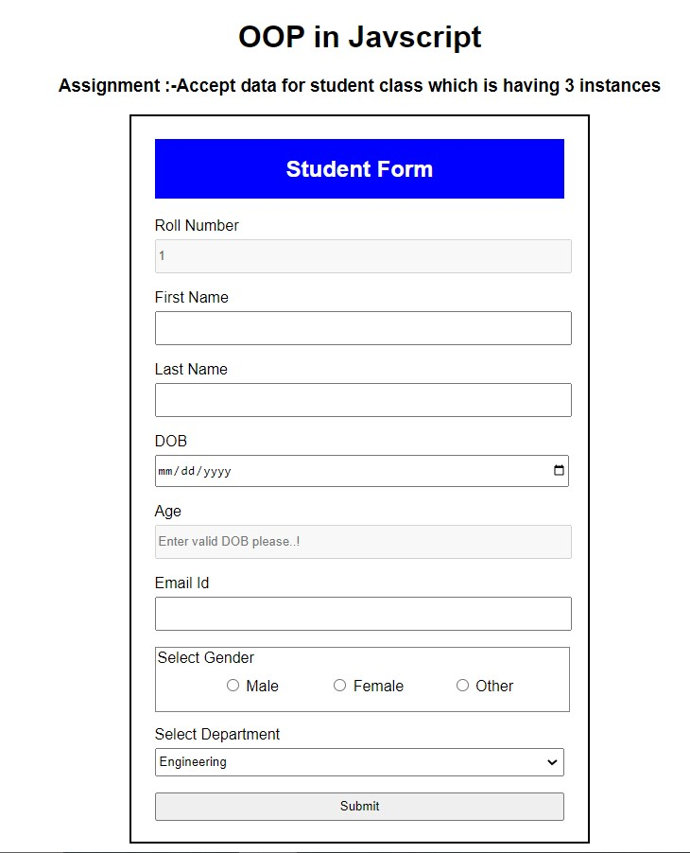

3)Entered first student data

-Here after selecting DOB age is automatically calculated.

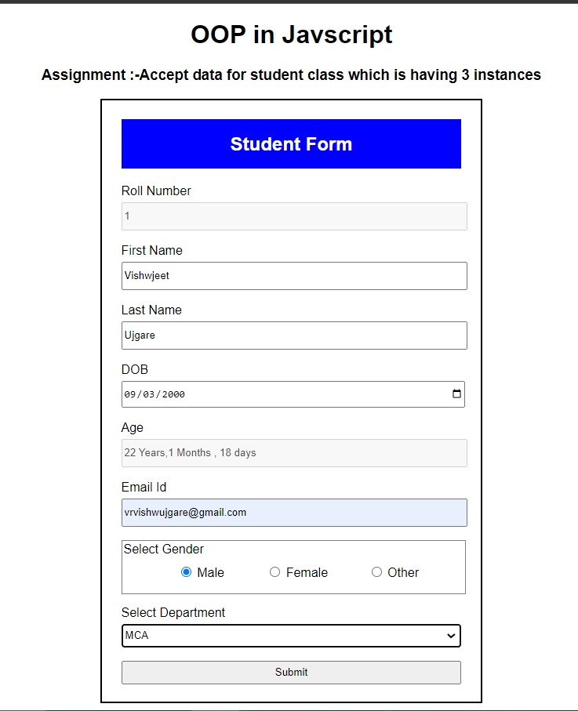

4) After Clicking on submit btn

-first student data is stored.

-previous form field is reset

-and Roll number for next student is generated automatically

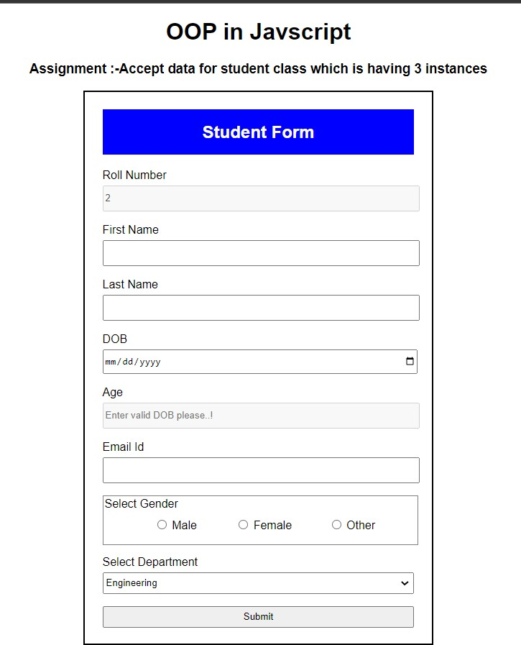

5)After filling the data for 3 students and clicking on submit button

-all 3 student data is displayed in the alert box

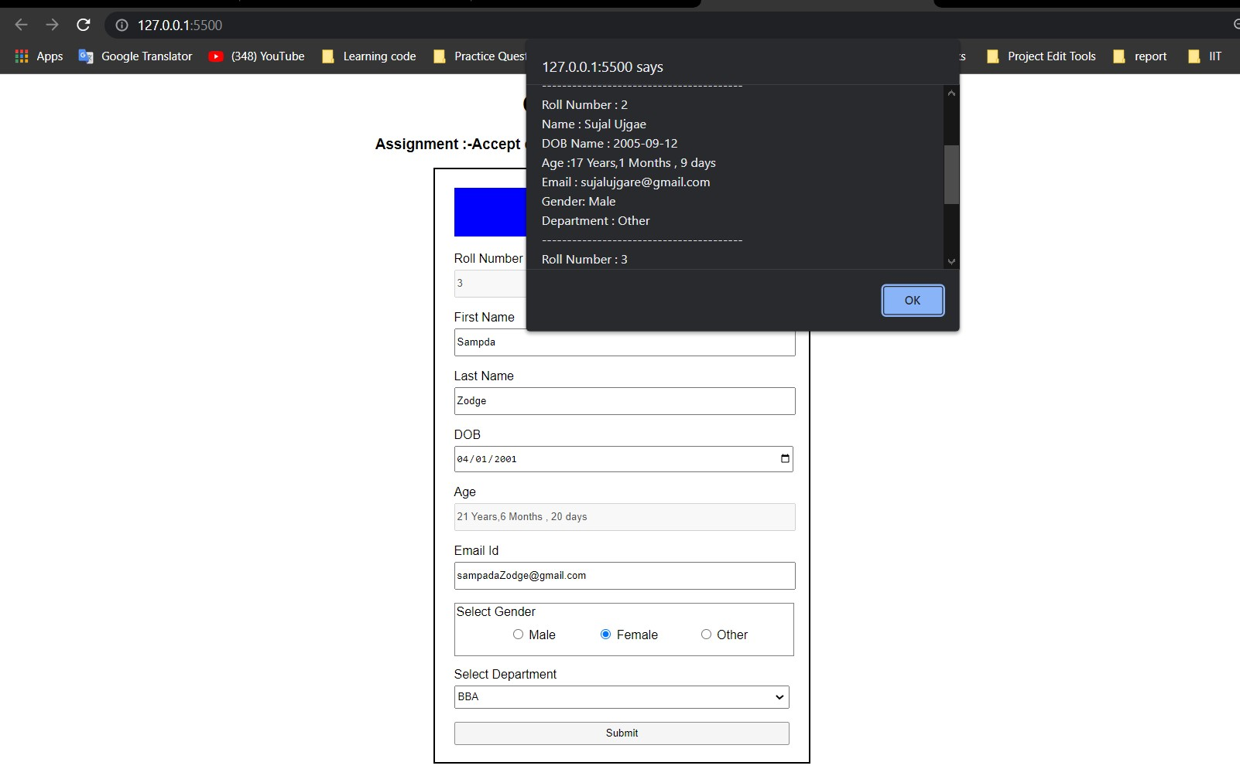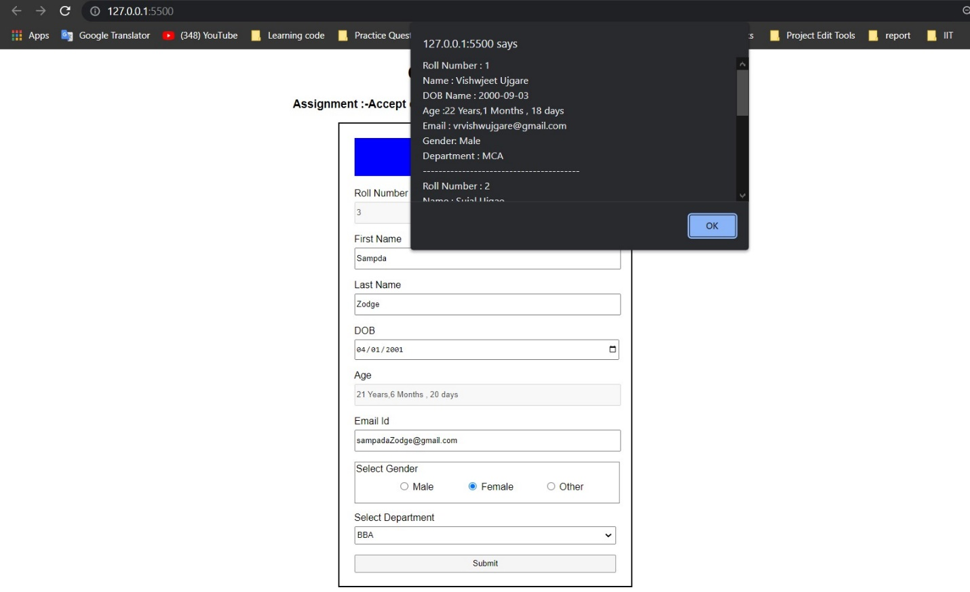

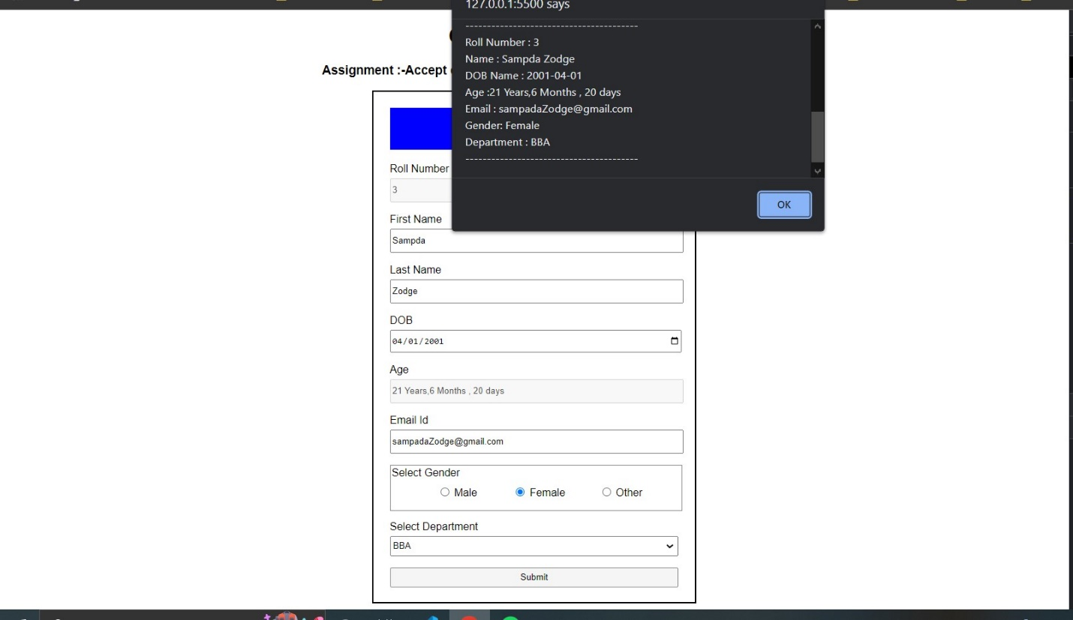

6)after clicking on ok button

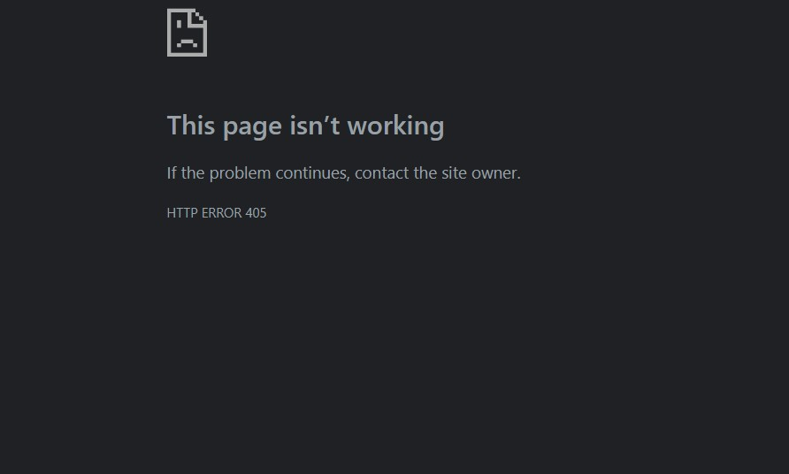-page is redirect to abc.php

**---------THANK YOU---------**